Week 3 – SOC Security Monitoring Cheat Sheet
Name: Ghanisth Mittal
Week: 3
Topic: Linux Logs, Sysmon, auditd and Snort
Purpose: This cheat sheet summarizes important Windows Event IDs, Sysmon events, Linux auditd events, and Snort alerts used for security monitoring and SOC investigation.

1. Windows Event Log Cheat Sheet

1. Event ID 4624 – Successful Logon
Description:
Event ID 4624 is generated when a user successfully logs on to a Windows system.
Important information:
- Username
- Logon type
- Source IP address
- Authentication information
- Timestamp
SOC Relevance:
Security analysts can use this event to identify successful logins and detect suspicious access, especially when the login comes from an unusual location or at an unusual time.
Example:
A successful login from an unknown IP address may require further investigation.

2. Event ID 4625 – Failed Logon
Description:
Event ID 4625 is generated when a logon attempt fails.
SOC Relevance:
Repeated failed logins can indicate:
- Brute-force attacks
- Password guessing
- Unauthorized access attempts
- Incorrect credentials
Example:
Multiple 4625 events from the same source IP may indicate a password-guessing attack.

3. Event ID 4688 – Process Creation
Description:
Event ID 4688 records when a new process is created on a Windows system.
SOC Relevance:
It helps analysts identify suspicious programs, scripts, or command-line activity.
Example:
Unexpected execution of PowerShell or a suspicious executable can be investigated using process creation events.

4. Event ID 4720 – User Account Created
Description:
Event ID 4720 is generated when a new user account is created.
SOC Relevance:
Attackers may create new accounts to maintain access to a compromised system.
Example:
If an administrator account creates an unexpected user account, the SOC should investigate it.

5. Sysmon Event ID 1 – Process Creation
Description:
Sysmon Event ID 1 records the creation of a new process.
Important information:
- Process name
- Process ID
- Parent process
- Command line
- User
- Timestamp
SOC Relevance:
It provides detailed process information and helps detect suspicious execution.
Example:
A suspicious PowerShell command launched by an unexpected parent process can be investigated.

6. Sysmon Event ID 3 – Network Connection
Description:
Sysmon Event ID 3 records network connections made by processes.
Important information:
- Source IP
- Destination IP
- Source port
- Destination port
- Process information
SOC Relevance:
It helps identify suspicious outbound or inbound network connections.
Example:
A workstation connecting to an unknown external IP can be investigated.

7. Sysmon Event ID 11 – File Creation
Description:
Sysmon Event ID 11 records when a file is created.
SOC Relevance:
It can help detect suspicious files created by malware, scripts, or unauthorized users.
Example:
A suspicious executable appearing in a temporary directory may require investigation.

8. Sysmon Event ID 22 – DNS Query
Description:
Sysmon Event ID 22 records DNS queries made by processes.
SOC Relevance:
It can help analysts identify suspicious domain lookups and potentially malicious communications.
Example:
A process repeatedly querying a suspicious domain can be investigated.

9. auditd – EXECVE
Description:
EXECVE records the execution of a program or command.
SOC Relevance:
It helps analysts determine which commands were executed on a Linux system.
Example:
sudo
bash
python
nmap
Suspicious commands can be investigated using audit logs.

10. auditd – USER_LOGIN
Description:
USER_LOGIN records user login activity.
SOC Relevance:
It helps monitor authentication and identify unusual login activity.
Example:
A login occurring at an unusual time or from an unexpected source can be investigated.

11. auditd – USER_AUTH
Description:
USER_AUTH records authentication-related activity.
SOC Relevance:
It helps analysts investigate authentication attempts and identify suspicious access patterns.
Example:
Repeated authentication failures may indicate password guessing.

12. Snort – ICMP Ping Detection
Rule:
alert icmp any any <> any any (msg:"ICMP Ping Detected"; sid:1000001; rev:2;)
Description:
This rule generates an alert when ICMP traffic is detected.
SOC Relevance:
ICMP traffic can be useful for identifying network discovery, host availability checks, and other network activity.
Alert Message:
ICMP Ping Detected
Verified in Lab:
Yes.

13. Snort – SSH Connection Attempt
Rule:
alert tcp any any -> $HOME_NET 22 (msg:"SSH Connection Attempt"; sid:1000002; rev:1;)
Description:
This rule detects TCP traffic directed toward port 22, which is commonly used by SSH.
SOC Relevance:
It helps monitor SSH connection attempts and can be useful when investigating unauthorized remote access or brute-force activity.
Alert Message:
SSH Connection Attempt
Verified in Lab:
Yes.

14. Snort – HTTP Traffic
Rule:
alert tcp any any -> $HOME_NET 80 (msg:"HTTP Traffic"; sid:1000003; rev:1;)
Description:
This rule detects TCP traffic directed toward port 80, commonly used for HTTP.
SOC Relevance:
It can help monitor HTTP traffic and investigate suspicious web-related network activity.
Alert Message:
HTTP Traffic
Lab Status:
The HTTP traffic was observed during testing, although the Snort alert was not consistently triggered.

15. Snort – MITRE ATT&CK T1046 Network Service Discovery
Rule:
alert tcp any any -> $HOME_NET any (msg:"MITRE T1046 - Possible Nmap SYN Scan"; flags:S; detection_filter:track by_src, count 10, seconds 5; classtype:attempted-recon; sid:1000004; rev:2;)
Description:
This rule detects a high number of TCP SYN packets from the same source within a short period. Such behavior can indicate an Nmap SYN scan.
MITRE ATT&CK Technique:
T1046 – Network Service Discovery
SOC Relevance:
Network service discovery is commonly used during reconnaissance to identify open ports and available services on a target system.
Lab Source:
Kali Linux: 192.168.144.128
Metasploitable: 192.168.144.129
Verified Alert:
MITRE T1046 - Possible Nmap SYN Scan
SID:
1000004
Revision:
2
Classification:
Attempted Information Leak
Verified in Lab:
Yes.

5. Quick SOC Investigation Reference
Event / Alert | What to Look For | Possible Security Concern
4624 | Successful login | Unauthorized access
4625 | Repeated failed logins | Brute force/password guessing
4688 | Suspicious process | Malware/unauthorized execution
4720 | Unexpected new account | Persistence/unauthorized account
Sysmon 1 | Suspicious process and command line | Malware/script execution
Sysmon 3 | Unknown network connection | Suspicious communication
Sysmon 11 | Suspicious file creation | Malware/dropper activity
Sysmon 22 | Suspicious DNS query | Malicious domain/C2 investigation
auditd EXECVE | Suspicious commands | Unauthorized activity
auditd USER_LOGIN | Unusual login | Unauthorized access
auditd USER_AUTH | Authentication failures | Password attacks
Snort ICMP | ICMP traffic | Network discovery/activity
Snort SSH | Port 22 connection | SSH access attempt
Snort HTTP | Port 80 traffic | Web traffic investigation
Snort T1046 | Multiple SYN packets | Network scanning/reconnaissance

6. Important Commands Used in the Lab

Check IP address
ip addr

Check network interface
ip link

Test connectivity
ping <IP-address>

Test whether a port is open
nc -vz <IP-address> <port>

Run Nmap SYN scan
sudo nmap -sS -p 1-1000 192.168.144.129

Validate Snort configuration
sudo snort -c /etc/snort/snort.lua -T

Start Snort with fast alerts
sudo snort -A alert_fast -q -c /etc/snort/snort.lua -i eth0

7. Verified Snort Lab Evidence
During the practical exercise, Snort successfully detected the Nmap SYN scan from Kali Linux to the Metasploitable machine.
Source:
192.168.144.128
Destination:
192.168.144.129
Detected Alert:
MITRE T1046 - Possible Nmap SYN Scan
SID:
1000004
Revision:
2
Classification:
Attempted Information Leak
The alert was generated against multiple destination ports, demonstrating that the Snort rule successfully detected the network scanning behavior.

8. Screenshot Evidence

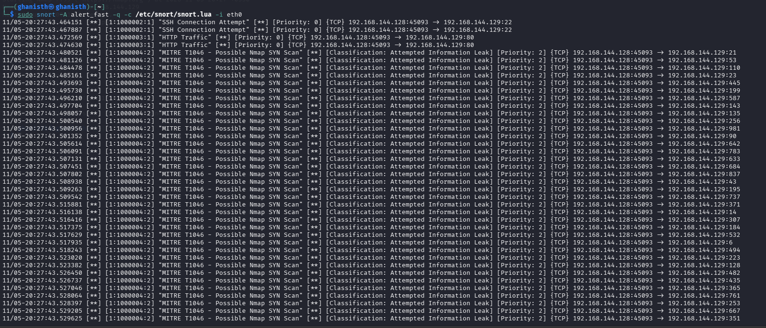
Figure 1: Snort detecting a possible Nmap SYN scan mapped to MITRE ATT&CK T1046 – Network Service Discovery.

9. Key SOC Concepts

Signature-Based Detection
Signature-based detection identifies known patterns or signatures associated with malicious activity.
Example:
A Snort rule designed to detect a particular network pattern.

Anomaly-Based Detection
Anomaly-based detection identifies activity that differs significantly from normal behavior.
Example:
A system suddenly making an unusually large number of network connections.

IDS
Intrusion Detection System (IDS) monitors activity and generates alerts when suspicious behavior is detected.

IPS
Intrusion Prevention System (IPS) can detect suspicious activity and also take action to block or prevent it.

SIEM
Security Information and Event Management (SIEM) collects and analyzes security logs from different systems in a centralized location.
Examples:
- Wazuh
- Splunk

